**Online Restaurants of The World**

1. **Starting page – after stopping server**

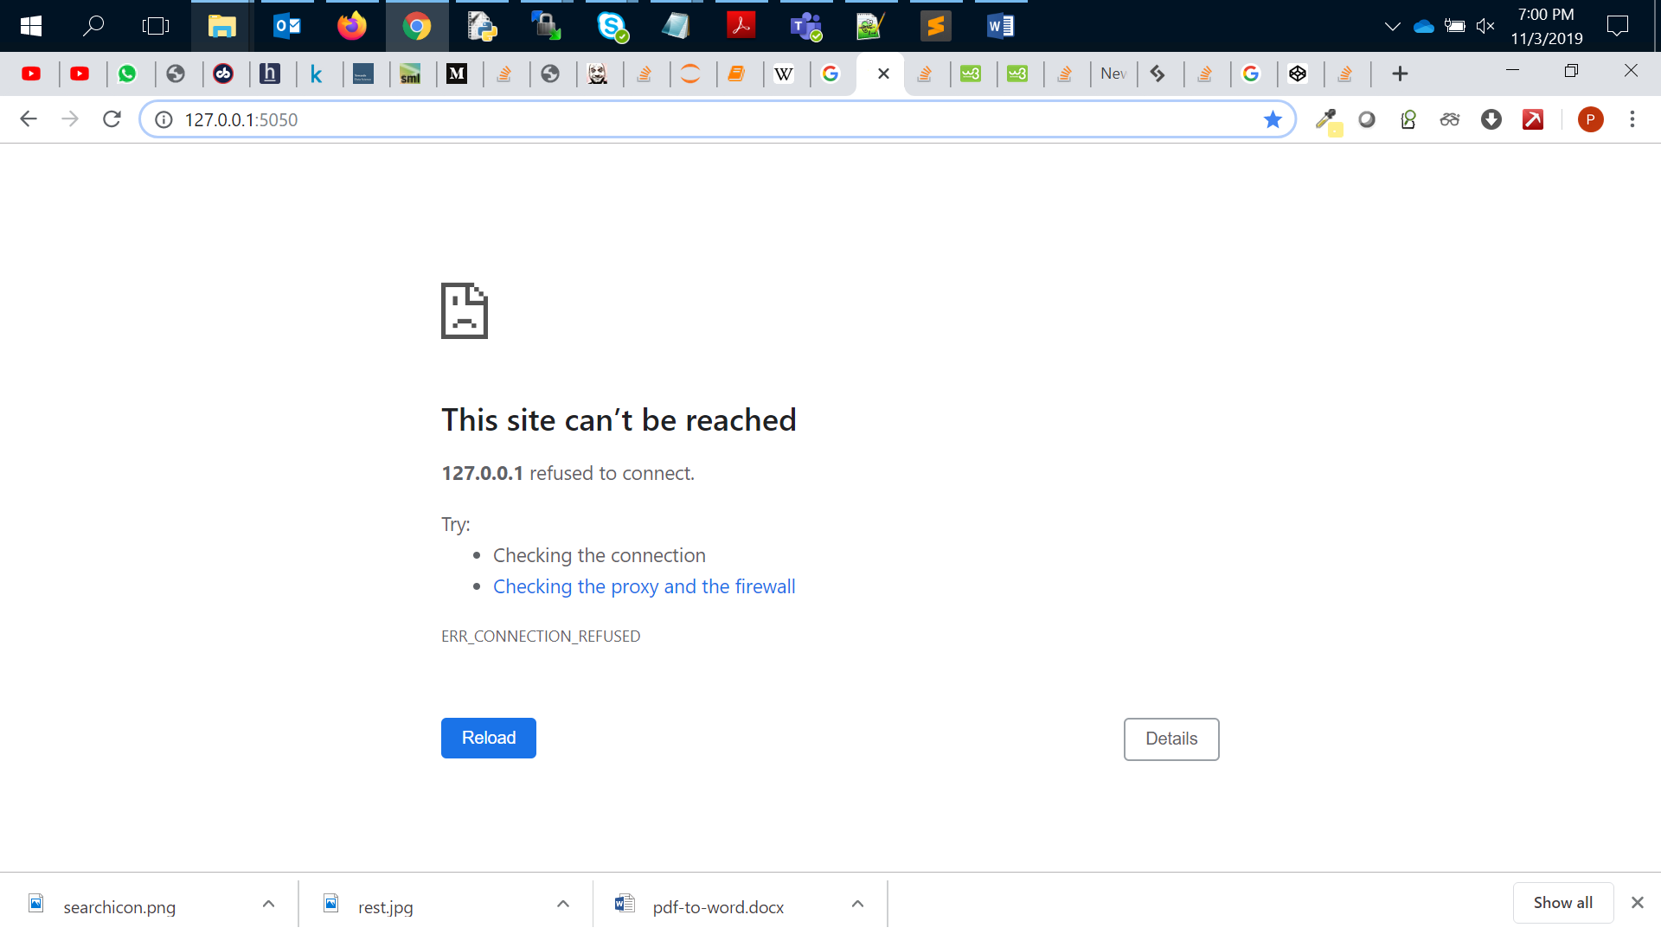

1. **Login to code folder** 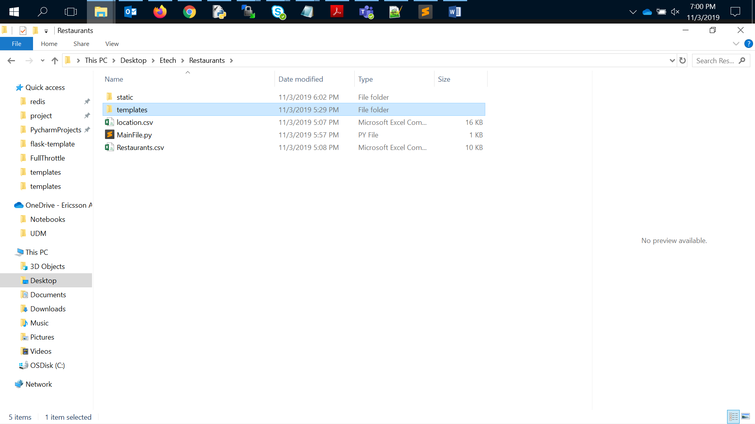
2. **Run “MainFile.py” from CMD :**

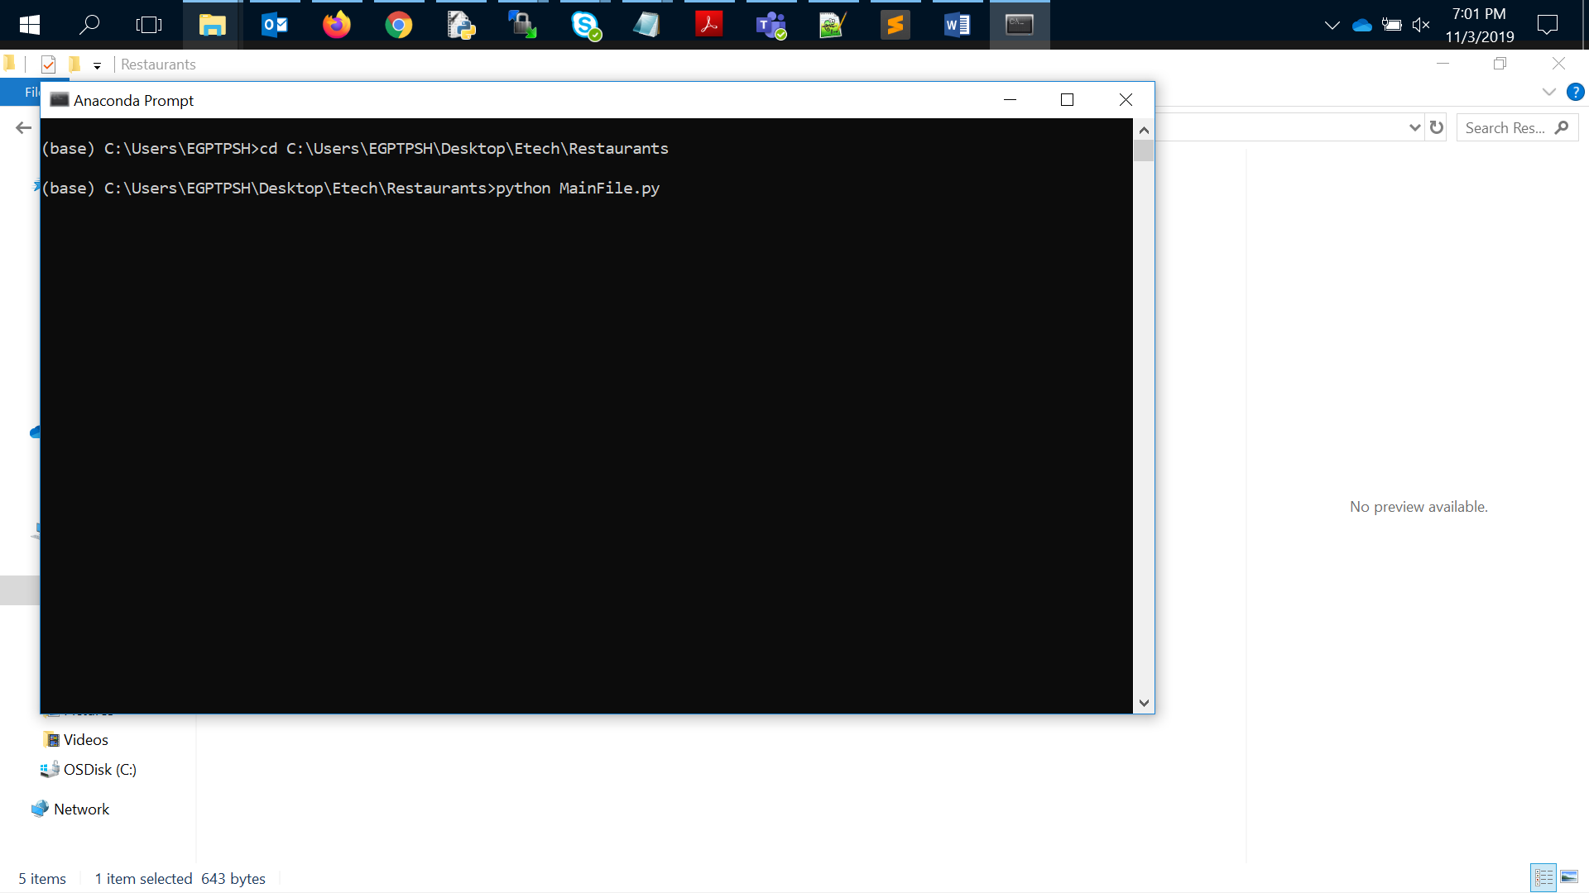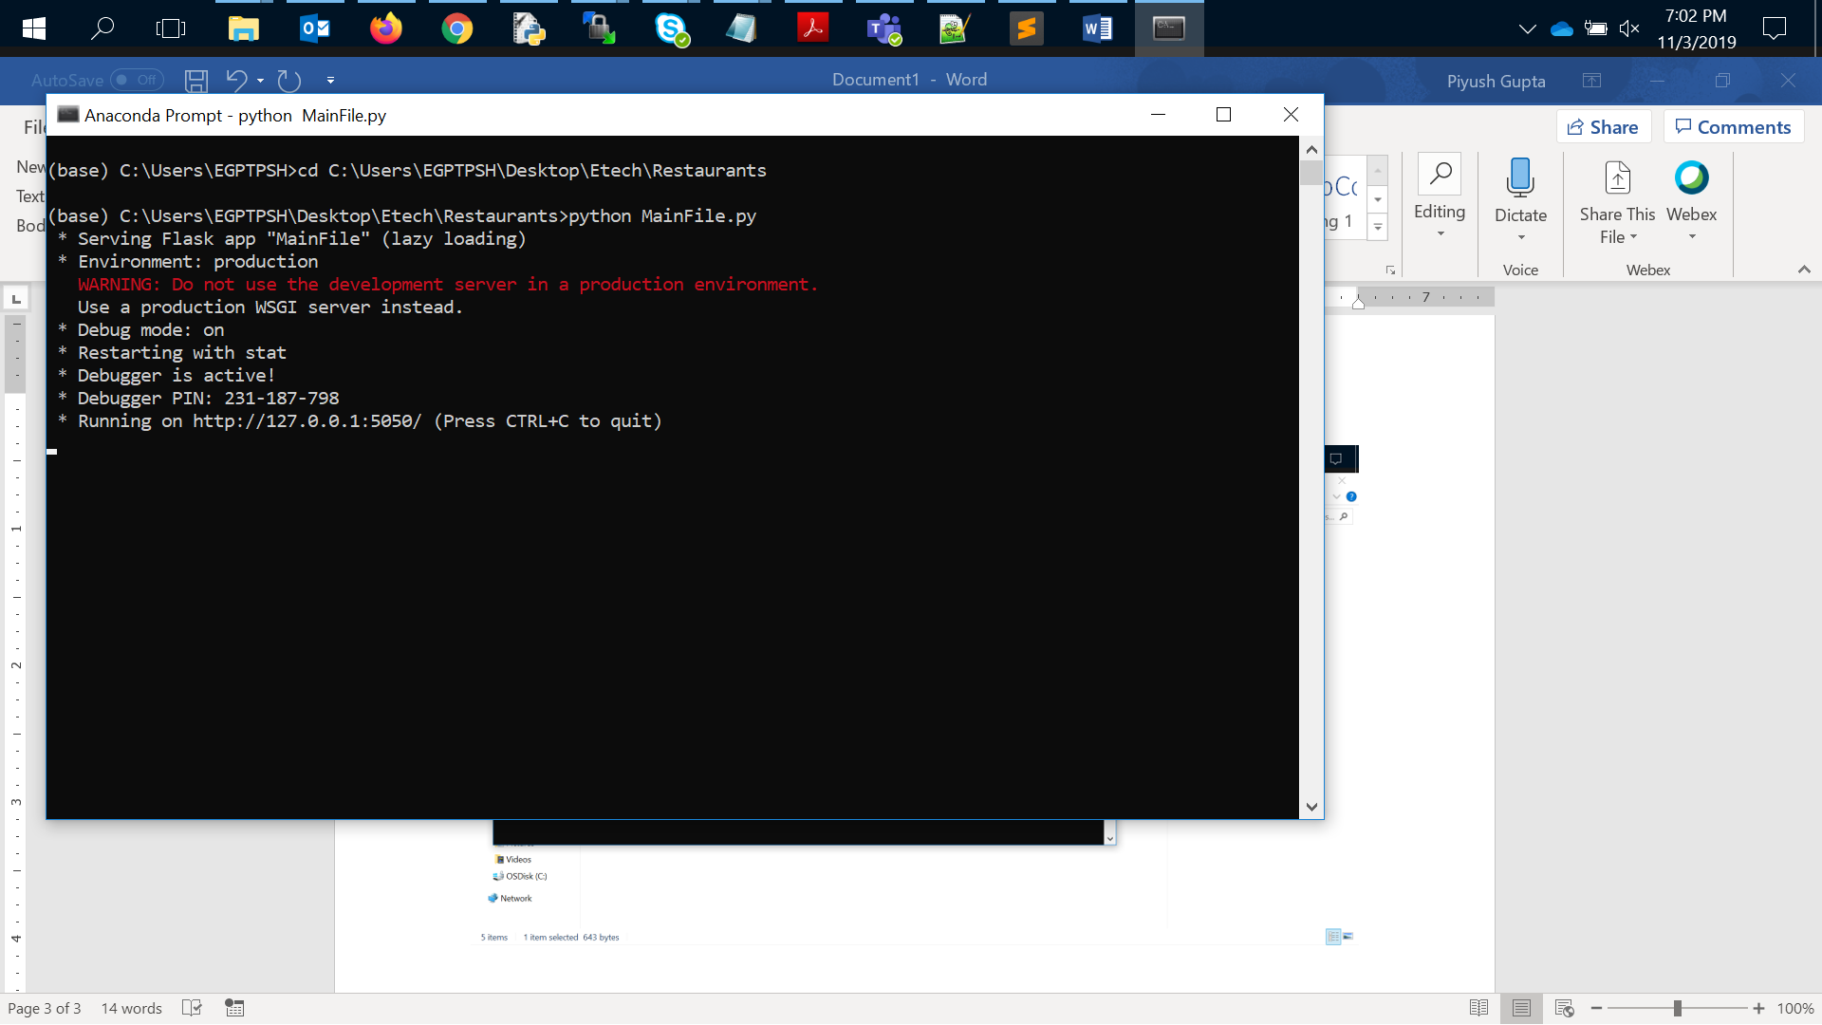

1. **Go to Any suitable browser and refresh the page with URL**

[***http://127.0.0.1:5050/***](http://127.0.0.1:5050/)

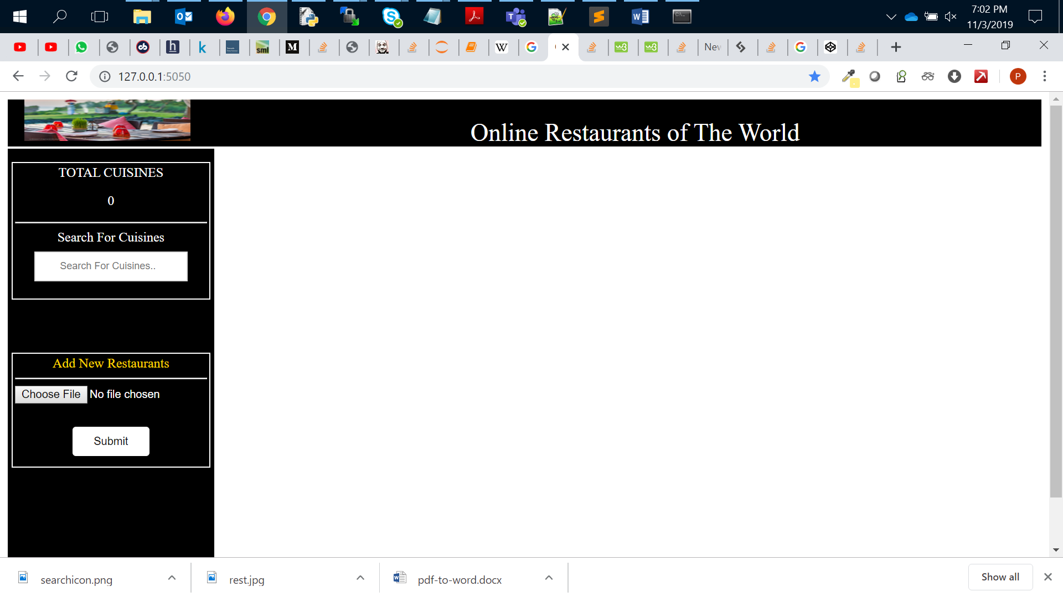

**As you can see the is image and all the block of code to upload a file a search bar and logo of Restaurants.**

1. **Upload the Restaurants details.** 
   * **Click on choose file**
   * **Move to selected folder**
   * **Select the file**
   * **Click on open**

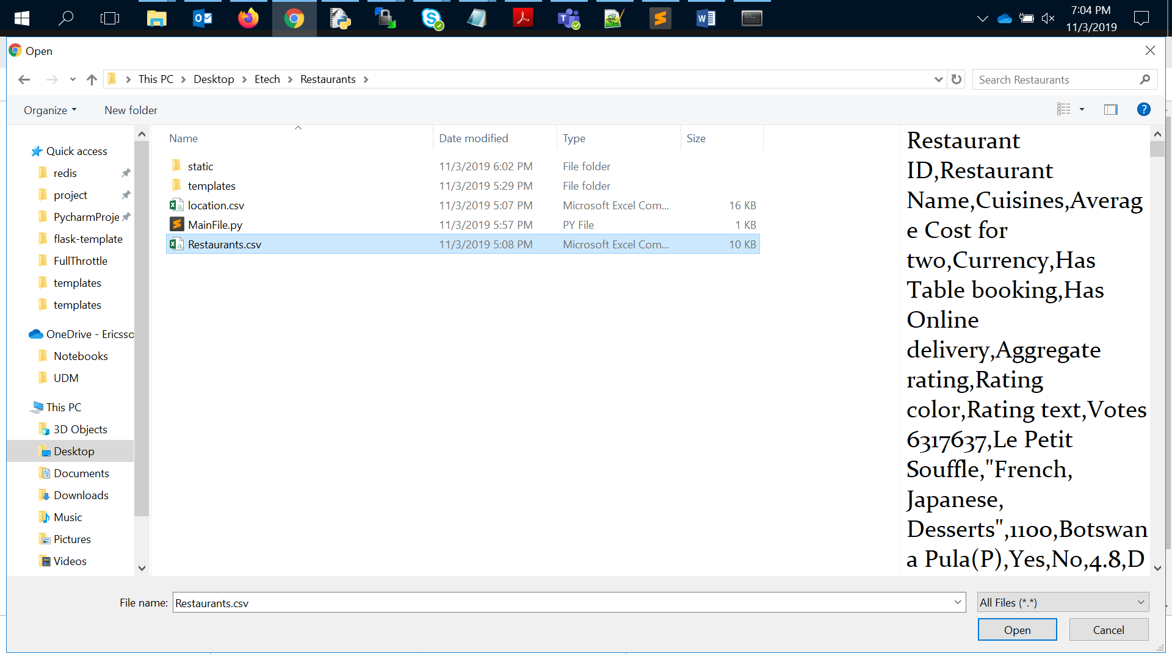

* + **Click on submit.**

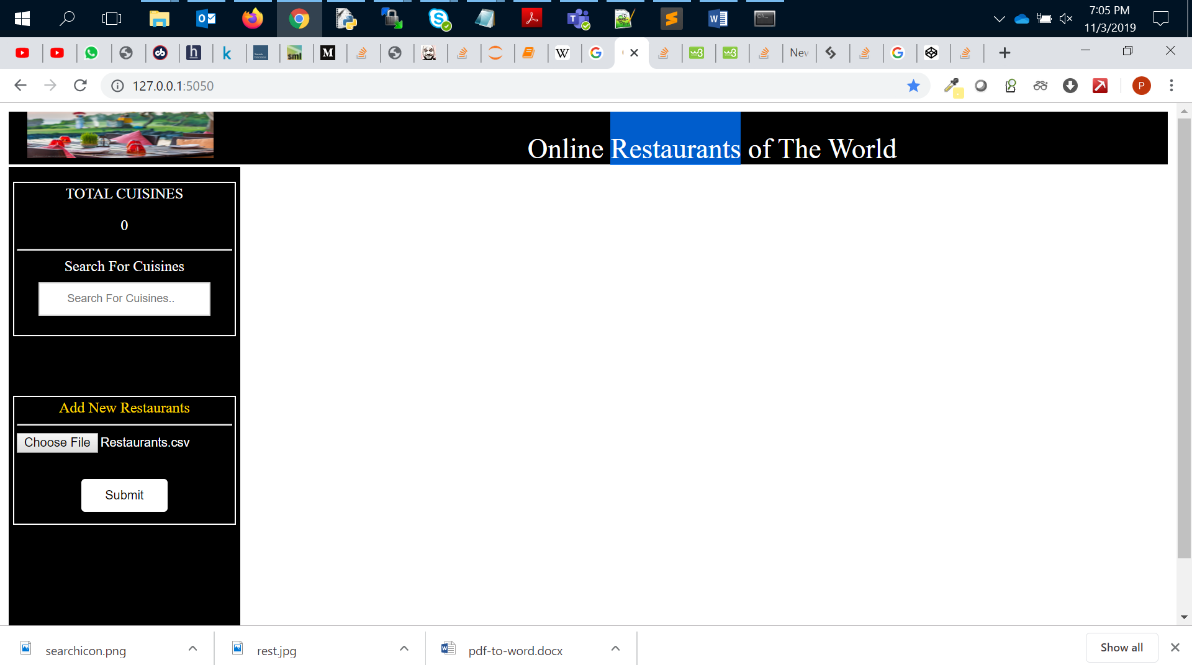

1. **You can see the below data that has been uploaded and same has been displayed on the page. (I used the same data provide by question site)**

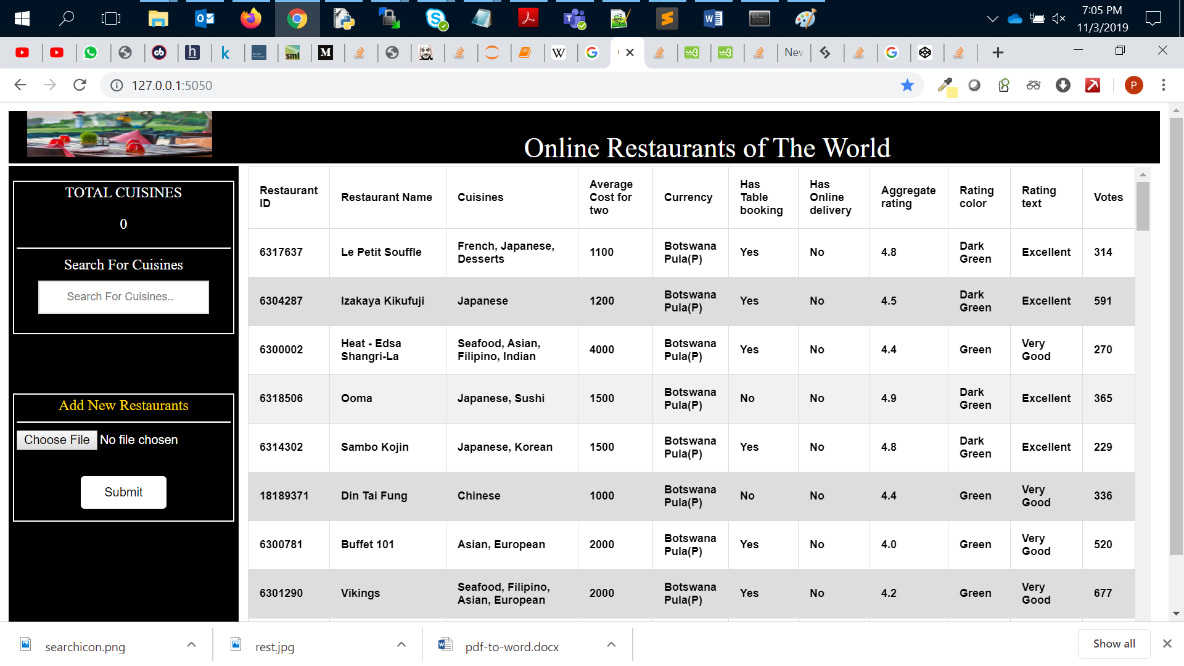

1. **You can use Finder and count will be updated after searching.(It will search all the Cuisines with name provided in the search bar and associated count for the search)**

